|  |
| --- |
| Electrical components Vectors & Illustrations for Free Download | Freepik |

**|| Arduino**

**pulse sensor ||**

**Heartbeat**

**Measurement**

we are going to make a Heart Beat Detection and Monitoring System using Arduino that will detect the heart beat using the Pulse Sensor and will display the reading in 16×2 LCD  in BPM (Beats Per Minute).This project is to demonstate how heartbeat measurement is done in smart watches, pulse oximeter etc.

Parts needed:

* Arduino UNO x 1
* 16 x 2 LCD Display x 1
* 10KΩ Potentiometer
* Heartbeat Sensor Module (finger based)
* Bread Board.
* Jumper Wires

Pulse Heart Rate Sensor:

Description:

**Δ**The heart rate sensor is designed to use an LED and a photoresistor to detect a heartbeat.

**Δ** Equipped with a series of signal conditioner on the back for accurate detection results.

**Δ**This sensor can be attached to the finger or ear (earring section).

**Δ**This sensor uses an IR LED and a photodetector, Where the pulse of your finger will effect the flow of light from the IR LED to the photodetector, this change is then converted, filtered and amplified by the sensor module for later processing by arduino.

Specifications:

|  |
| --- |
| Pulse Sensor and Arduino - Interfacing    PIN CONFIGURATION IN   PULSE SENSOR |

The main specifications of this sensor mainly include the following.

* This is a hear beat detecting and biometric pulse rate sensor
* Its diameter is 0.625
* Its thickness is 0.125
* The operating voltage is ranges +5V otherwise +3.3V
* This is a plug and play type sensor
* The current utilization is 4mA
* Includes the circuits like Amplification & Noise cancellation
* This pulse sensor is not approved by the FDA or medical. So it is used in student-level projects, not for the commercial purpose in health issues applications.

Applications:

* Measures a sports athelete’s heart rate
* Laboratory experiments
* Artists and game makers
* Learning tools

Schematics:

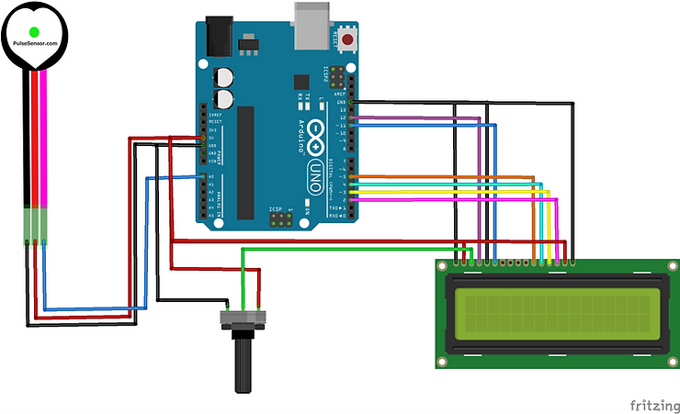

Working Code:-

//Heart Pulse Sensor

#include <LiquidCrystal.h>

const int rs = 12, en = 11, d4 = 5, d5 = 4, d6 = 3, d7 = 2;

LiquidCrystal lcd(12, 11, 5, 4, 3, 2);

int pulsePin = A0; // Pulse Sensor purple wire connected to analog pin A0

int blinkPin = 13; // pin to blink led at each beat

// Volatile Variables, used in the interrupt service routine!

volatile int BPM; // int that holds raw Analog in 0. updated every 2mS

volatile int Signal; // holds the incoming raw data

volatile int IBI = 600; // int that holds the time interval between beats! Must be seeded!

volatile boolean Pulse = false; // "True" when User's live heartbeat is detected. "False" when not a "live beat".

volatile boolean QS = false; // becomes true when Arduoino finds a beat.

static boolean serialVisual = true; // Set to 'false' by Default. Re-set to 'true' to see Arduino Serial Monitor ASCII Visual Pulse

volatile int rate[10]; // array to hold last ten IBI values

volatile unsigned long sampleCounter = 0; // used to determine pulse timing

volatile unsigned long lastBeatTime = 0; // used to find IBI

volatile int P = 512; // used to find peak in pulse wave, seeded

volatile int T = 512; // used to find trough in pulse wave, seeded

volatile int thresh = 525; // used to find instant moment of heart beat, seeded

volatile int amp = 100; // used to hold amplitude of pulse waveform, seeded

volatile boolean firstBeat = true; // used to seed rate array so we startup with reasonable BPM

volatile boolean secondBeat = false; // used to seed rate array so we startup with reasonable BPM

void setup()

{

pinMode(blinkPin,OUTPUT); // pin that will blink to your heartbeat!

Serial.begin(115200); // we agree to talk fast!

interruptSetup(); // sets up to read Pulse Sensor signal every 2mS

// IF YOU ARE POWERING The Pulse Sensor AT VOLTAGE LESS THAN THE BOARD VOLTAGE,

// UN-COMMENT THE NEXT LINE AND APPLY THAT VOLTAGE TO THE A-REF PIN

// analogReference(EXTERNAL);

lcd.begin(16, 2);

lcd.clear();

}

// Where the Magic Happens

void loop()

{

serialOutput();

if (QS == true) // A Heartbeat Was Found

{

// BPM and IBI have been Determined

// Quantified Self "QS" true when arduino finds a heartbeat

serialOutputWhenBeatHappens(); // A Beat Happened, Output that to serial.

QS = false; // reset the Quantified Self flag for next time

}

delay(20); // take a break

}

void interruptSetup()

{

// Initializes Timer2 to throw an interrupt every 2mS.

TCCR2A = 0x02; // DISABLE PWM ON DIGITAL PINS 3 AND 11, AND GO INTO CTC MODE

TCCR2B = 0x06; // DON'T FORCE COMPARE, 256 PRESCALER

OCR2A = 0X7C; // SET THE TOP OF THE COUNT TO 124 FOR 500Hz SAMPLE RATE

TIMSK2 = 0x02; // ENABLE INTERRUPT ON MATCH BETWEEN TIMER2 AND OCR2A

sei(); // MAKE SURE GLOBAL INTERRUPTS ARE ENABLED

}

void serialOutput()

{ // Decide How To Output Serial.

if (serialVisual == true)

{

arduinoSerialMonitorVisual('-', Signal); // goes to function that makes Serial Monitor Visualizer

}

else

{

sendDataToSerial('S', Signal); // goes to sendDataToSerial function

}

}

void serialOutputWhenBeatHappens()

{

if (serialVisual == true) // Code to Make the Serial Monitor Visualizer Work

{

Serial.print(" Heart-Beat Found "); //ASCII Art Madness

Serial.print("BPM: ");

Serial.println(BPM);

lcd.print("Heart-Beat Found ");

lcd.setCursor(1,1);

lcd.print("BPM: ");

lcd.setCursor(5,1);

lcd.print(BPM);

delay(300);

lcd.clear();

}

else

{

sendDataToSerial('B',BPM); // send heart rate with a 'B' prefix

sendDataToSerial('Q',IBI); // send time between beats with a 'Q' prefix

}

}

void arduinoSerialMonitorVisual(char symbol, int data )

{

const int sensorMin = 0; // sensor minimum, discovered through experiment

const int sensorMax = 1024; // sensor maximum, discovered through experiment

int sensorReading = data; // map the sensor range to a range of 12 options:

int range = map(sensorReading, sensorMin, sensorMax, 0, 11);

// do something different depending on the

// range value:

}

void sendDataToSerial(char symbol, int data )

{

Serial.print(symbol);

Serial.println(data);

}

ISR(TIMER2_COMPA_vect) //triggered when Timer2 counts to 124

{

cli(); // disable interrupts while we do this

Signal = analogRead(pulsePin); // read the Pulse Sensor

sampleCounter += 2; // keep track of the time in mS with this variable

int N = sampleCounter - lastBeatTime; // monitor the time since the last beat to avoid noise

// find the peak and trough of the pulse wave

if(Signal < thresh && N > (IBI/5)*3) // avoid dichrotic noise by waiting 3/5 of last IBI

{

if (Signal < T) // T is the trough

{

T = Signal; // keep track of lowest point in pulse wave

}

}

if(Signal > thresh && Signal > P)

{ // thresh condition helps avoid noise

P = Signal; // P is the peak

} // keep track of highest point in pulse wave

// NOW IT'S TIME TO LOOK FOR THE HEART BEAT

// signal surges up in value every time there is a pulse

if (N > 250)

{ // avoid high frequency noise

if ( (Signal > thresh) && (Pulse == false) && (N > (IBI/5)*3) )

{

Pulse = true; // set the Pulse flag when we think there is a pulse

digitalWrite(blinkPin,HIGH); // turn on pin 13 LED

IBI = sampleCounter - lastBeatTime; // measure time between beats in mS

lastBeatTime = sampleCounter; // keep track of time for next pulse

if(secondBeat)

{ // if this is the second beat, if secondBeat == TRUE

secondBeat = false; // clear secondBeat flag

for(int i=0; i<=9; i++) // seed the running total to get a realisitic BPM at startup

{

rate[i] = IBI;

}

}

if(firstBeat) // if it's the first time we found a beat, if firstBeat == TRUE

{

firstBeat = false; // clear firstBeat flag

secondBeat = true; // set the second beat flag

sei(); // enable interrupts again

return; // IBI value is unreliable so discard it

}

// keep a running total of the last 10 IBI values

word runningTotal = 0; // clear the runningTotal variable

for(int i=0; i<=8; i++)

{ // shift data in the rate array

rate[i] = rate[i+1]; // and drop the oldest IBI value

runningTotal += rate[i]; // add up the 9 oldest IBI values

}

rate[9] = IBI; // add the latest IBI to the rate array

runningTotal += rate[9]; // add the latest IBI to runningTotal

runningTotal /= 10; // average the last 10 IBI values

BPM = 60000/runningTotal; // how many beats can fit into a minute? that's BPM!

QS = true; // set Quantified Self flag

// QS FLAG IS NOT CLEARED INSIDE THIS ISR

}

}

if (Signal < thresh && Pulse == true)

{ // when the values are going down, the beat is over

digitalWrite(blinkPin,LOW); // turn off pin 13 LED

Pulse = false; // reset the Pulse flag so we can do it again

amp = P - T; // get amplitude of the pulse wave

thresh = amp/2 + T; // set thresh at 50% of the amplitude

P = thresh; // reset these for next time

T = thresh;

}

if (N > 2500)

{ // if 2.5 seconds go by without a beat

thresh = 512; // set thresh default

P = 512; // set P default

T = 512; // set T default

lastBeatTime = sampleCounter; // bring the lastBeatTime up to date

firstBeat = true; // set these to avoid noise

secondBeat = false; // when we get the heartbeat back

}

sei(); // enable interrupts when youre done!

}// end isr